SniffyPro: Projects #1, #2, & #3

Sniffy Project #1:

Baseline Behavior Observational Record:
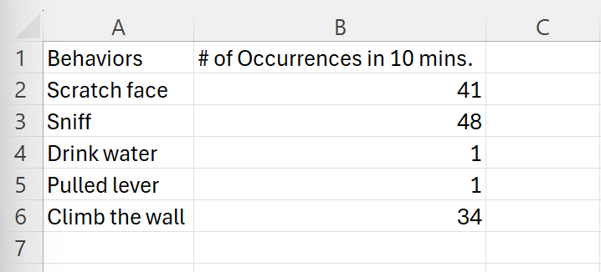

(Keep scrolling down for “SniffyPro: Projects #2 & #3” answers)

(Project #2 wouldn’t fit on this page with Project #1)

Sniffy Project #2:
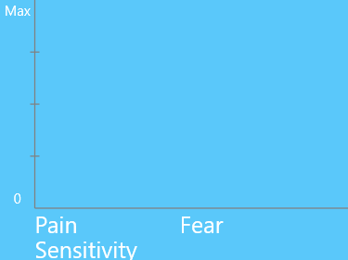
Low Intensity:

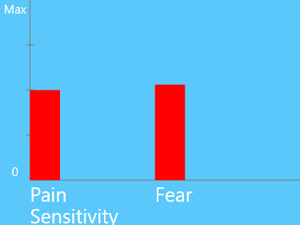
Medium Intensity:

High Intensity:
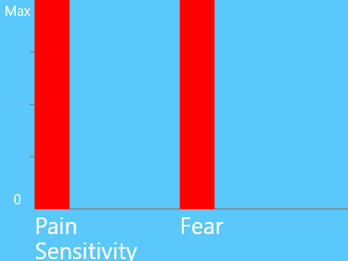

“Interpret the Movement Ratio and CS Response strength results:”
Comparing the results of all 3 conditions (low, medium, and high intensity CS groups), there is a roughly two-fold increase in both the “Movement Ratio” data as well as the “CS Response Strength” data. This overall trend of an increase (and seemingly a constant magnitude of increase) in both data sets implies two takeaways:
- The noticeable and steady increase in the “Movement Ratio” data visualizes the fact that there is a change in the rat’s behavior (more specifically, it implies an increase in freezing behaviors). As the intensity of the CS itself increases, so does the movement ratio (greater shocks produces increased freezing behaviors)
- The noticeable and steady increase in the “CS Response Strength” data relays the fact that there is a change in the rat’s learning (psychological state), which we know will affect its behavior. If there is an increase in the movement ratio (which measures change in behavior), exactly like what we saw in my “Project 2” results, then we know that the CS is the cause for freezing behaviors/

(Keep scrolling down for “SniffyPro: Project #3” answers)

(Project #3 wouldn’t fit on this page with Project #2)

Sniffy Project #3:

Exercise #3:

Exercise #4:
(Low intensity) (High intensity)
(exercise #4 excel graph) (exercise #5 excel graph)
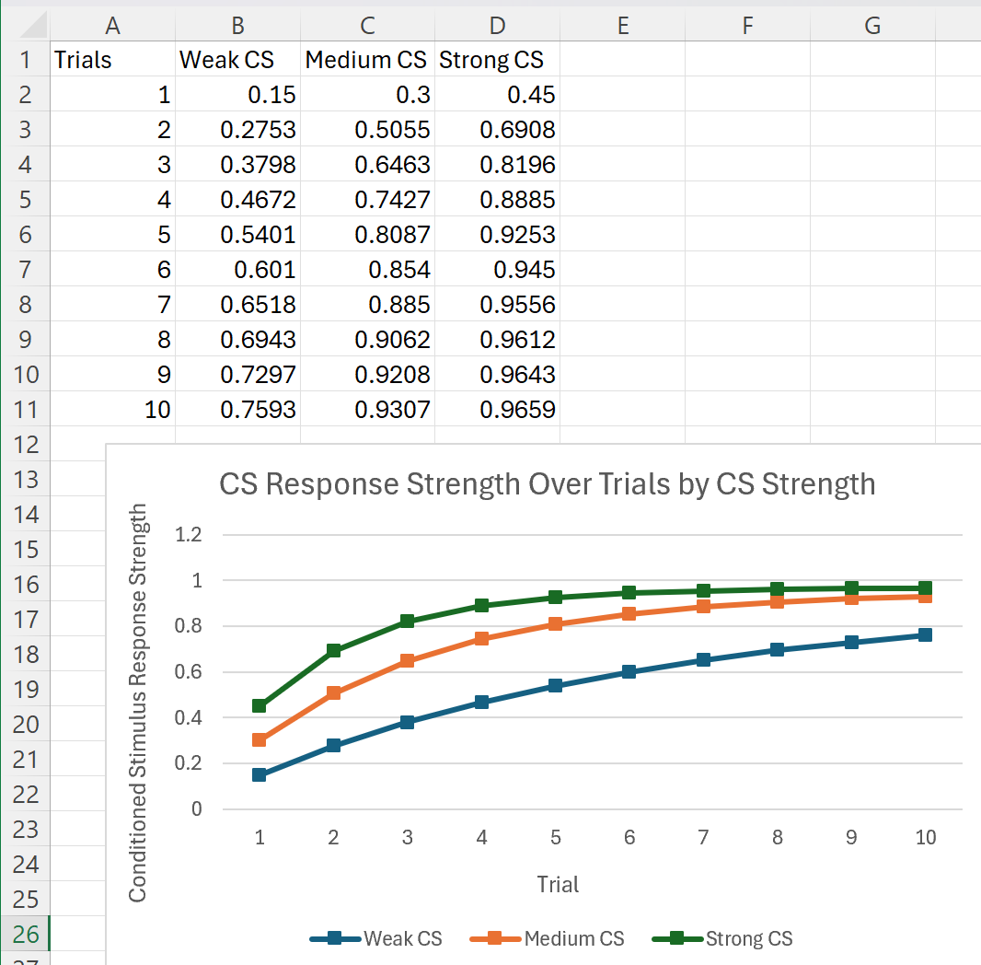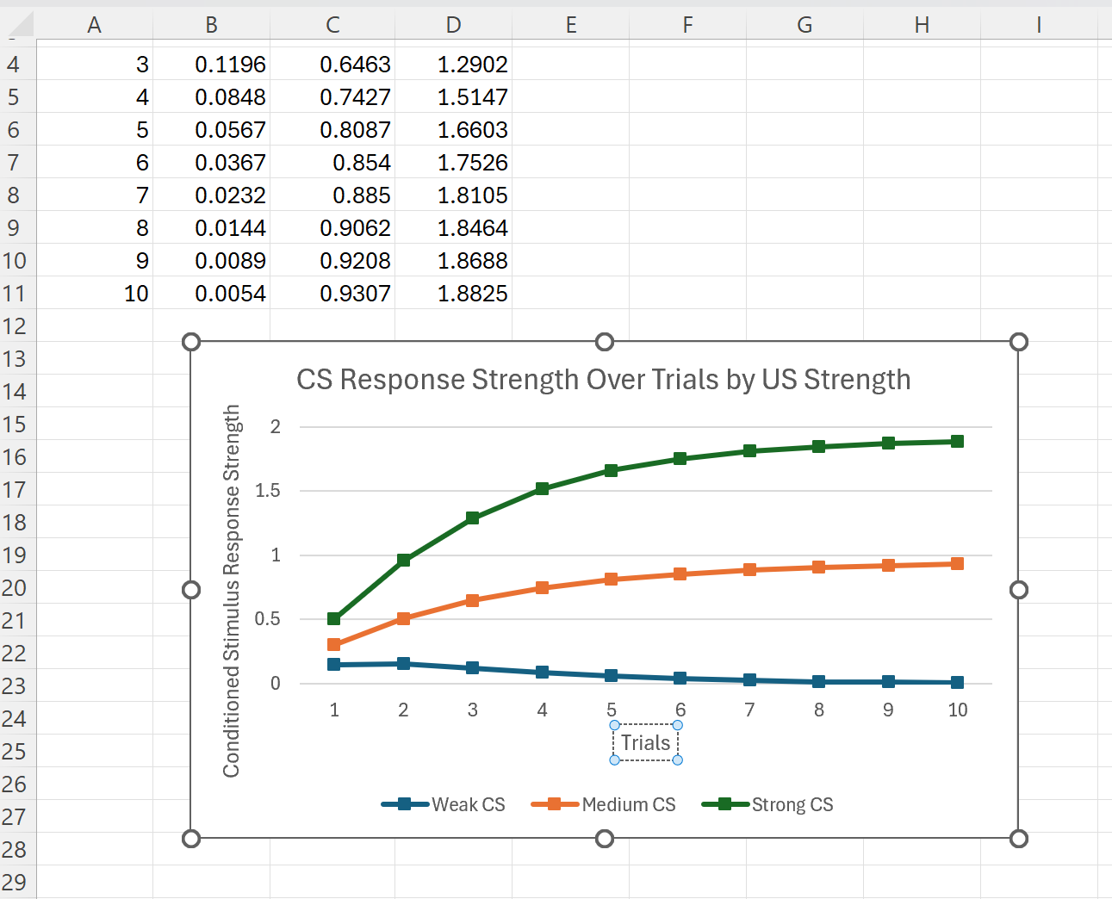

Exercise #5:
(Low intensity) (High intensity)

Interpretation of the results from exercises #3 - #5:
- As the trials progressed without the shock, the rat's reaction to the tone gradually faded. This drop in CS response strength over the 15 extinction trials suggests that the learned fear started to wear off. We also saw a decline in the Movement Ratio, meaning the rat was freezing less and behaving more normally. Without the shock backing it up, the tone lost its power to trigger fear — showing how the conditioned response relies on continued reinforcement to stick around.
- When the tone was louder, the rat caught on much quicker (it started showing a fear response sooner than it did with the quieter tones). That being said, by the time all 10 trials were done, even the low and medium tones reached about the same response level. So while a stronger tone speeds up the learning process, it doesn't necessarily lead to a stronger final response. The intensity of the CS just changes how fast the rat learns, not how well.
- Using a stronger shock made the rat learn the fear response faster and more intensely. The medium shock showed steady learning, while the weaker shock led to slower progress (and even signs that the rat was getting used to it…not more afraid). That difference shows how the strength of the unconditioned stimulus does not just affect how quickly conditioning happens, but also how strong the fear response becomes. A higher intensity shock makes a bigger and longer-lasting impact.

